How many CPU cores are displayed?.
12
What are the values for L1, L2, and L3 cache?
768KB, 6.0MB, 64.0MB in the order mentioned above
What is the purpose of the L1, L2, and L3 cache?
Memory is cached so the CPU has quick access to data when it wants to read, otherwise the CPU would have to wait until the next set of instructions. With data cached, a program can be quickly executed. Each cache is different where L1 is the fastest running at the same speed of the CPU, the trade off is it is typically smaller the other caches but is integral to modern CPUS. L2s are slower but have more memory than the L1s. L3s were previously apart of the motherboard but is not a part of the CPU and can cache more than 16MB depending on the hardware specifications.
Do you have an SSD drive?
Yes, it stores my OS for quicker boot times.
What process is using the highest % of CPU?
System Idle Process
What is the % value for the system idle process?
96
Include a screen print of your Resource Monitor.
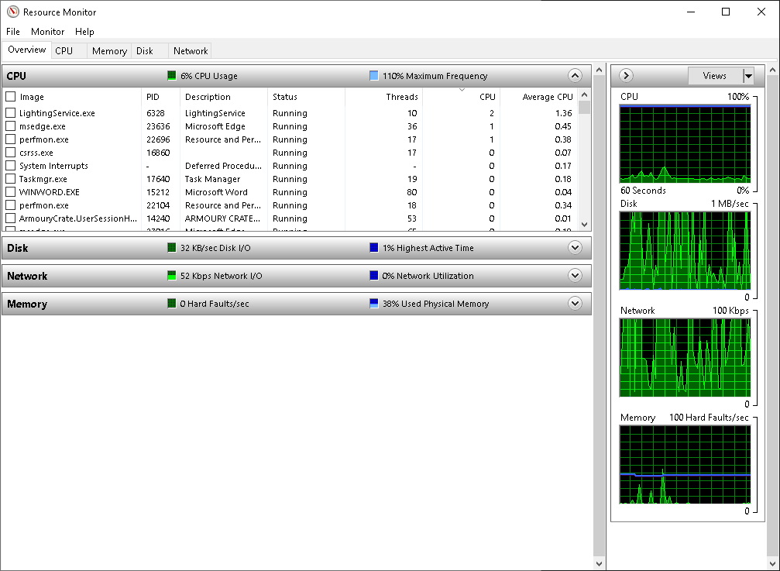

In Module 3 of Guide to Operating Systems by Greg Tomsho, I learned a lot more about how the CPU actually works beyond just being the “brain” of the computer. The way it processes instructions and keeps things moving really stood out to me. One of the coolest things I picked up was how the cache system works. Before this, I didn’t realize just how important those layers of L1, L2, and L3 cache were in making the CPU efficient. It makes sense now why some data feels instantly available—it’s literally sitting right there in the fastest cache.
I also got a clearer idea of what clock speed and overclocking really mean. As someone who has built their own PC, I’ve seen those terms thrown around a lot, but now I get what’s happening under the hood. Overclocking isn’t just a way to “make it faster”—it’s really pushing the CPU to process more cycles than it was designed for, which can make things hotter and less stable if you’re not careful. That gave me a new appreciation for why good cooling setups matter so much.
Overall, it feels great seeing how everything ties together and knowing my system is running efficiently. Having built my own computer, it’s rewarding to connect what I learned in the module with the choices I made in my build. It makes the whole process of putting a PC together feel even more worth it.

